

**Triathlon Scotland 2019 National**

**Youth Triathlon Championships**

**Sunday 23rd June 2019, Bellahouston Park Glasgow**

**R A C E I N F O R M A T I O N**

Thank you for your entry to the National Youth Triathlon Championships.

This document will let you know what to expect on the day. Please read it carefully.

**Event information**

This year we have 350 entries making it the biggest and best junior triathlon in Scotland. The race follows a similar format to last year’s event. The race details below should give you the information you need for things to go smoothly on race day but feel free to ask any question via email or when you arrive on Sunday.

**Race Timetable**

|  |  |
| --- | --- |
| 8:00 - 09:30 | Registration and Transition Set Up |
| 09:40 – 10:00 | Compulsory Race Briefing in the Leisure Centre Sports Hall |

|  |  |  |  |  |  |  |
| --- | --- | --- | --- | --- | --- | --- |
|  |  |  |  |  |  |  |
| **Time** | **Heat** | **Category** | **Age** | **Swim** | **Bike** | **Run** |
| 10:15 | HEAT 1 | Tristar Start – boys | 8yrs | 50m (2 lengths) | 1.4k  1 small lap | 600m  1 small lap |
| 10:30 | HEAT 2 | Tristar Start - girls | 8 yrs | 50m (2 lengths) | 1.4k  1 small lap | 600m  1 small lap |
| 10:45 | HEAT 3 | Tristar 1 - boys | 9-10 yrs | 150m (6 lengths) | 4k  2 laps | 1200m  2 small laps |
| 11:05 | HEAT 4 | Tristar 1 - boys | 9-10 yrs | 150m (6 lengths) | 4k  2 laps | 1200m  2 small laps |
| 11:25 | Heat 5 | Tristar 1 – Girls | 9-10 yrs | 150m (6 lengths) | 4km  2 laps | 1200m  2 small laps |
| 11:45 | HEAT 6 | Tristar 1 - girls | 9-10 yrs | 150m (6 lengths) | 4k  2 laps | 1200m  2 small laps |
| 12:05 | HEAT 7 | Tristar 2 - boys | 11-12 yrs | 200m (8 lengths) | 6k  3 laps | 1800m  2 laps |
| 12:25 | HEAT 8 | Tristar 2 - boys | 11-12 yrs | 200m (8 lengths) | 6k  3 laps | 1800m  2 laps |
| 12:45 | HEAT 9 | Tristar 2 - girls | 11-12 yrs | 200m (8 lengths) | 6k  3 laps | 1800m  2 laps |
| 13:05 | HEAT 10 | Tristar 2 - girls | 11-12 yrs | 200m (8 lengths) | 6k  3 laps | 1800m  2 laps |
| 14:00 | Tristar Start, | Tristar 1 and 2 Prizegiving |  |  |  |  |
| 13:25 | HEAT 11 | Tristar 3 - boys | 13-14 yrs | 300m (12 lengths) | 8k  4 laps | 2400m  2 laps |
| 13:50 | HEAT 12 | Tristar 3 - boys | 13-14 yrs | 300m (12 lengths) | 8k  4 laps | 2400m  2 laps |
| 14:15 | HEAT 13 | Tristar 3 - girls | 13-14 yrs | 300m (12 lengths) | 8k  4 laps | 2400m  2 laps |
| 14:40 | HEAT 14 | Youth Champs - Male | 15-16 yrs | 400m (16 lengths) | 10k  5 laps | 3000m  2 laps |
| 15:10 | HEAT 15 | Youth Champs - Female | 15-16 yrs | 400m (16 lengths) | 10k  5 laps | 3000m  2 laps |
| 15:40 | HEAT 16 | Go Tri IT - Mixed | 16+ yrs | 400m (16 lengths) | 10k  5 laps | 3000m  2 laps |
| 16:00 | Prize Giving |  |  |  |  |  |

**Before you leave home**

Remember to bring with you:

* Race licence. (If you said you were a Triathlon Scotland member when you entered online you must bring your Race Licence. Otherwise you will have to pay a £2 surcharge at registration.)
* Swimwear and goggles. A swim cap will be provided at the swim start.
* Your bike and a helmet (NO helmet = NO race).
* Running and cycling kit and shoes.
* Safety pins to attach your race number to your top for the run and bike sections or a race belt. Your race number should be attached to the front of your top so that it can be clearly seen by the lap counters on the cycle and run sections and by the finish timers. If using a race belt, the number should be to the back on the bike and the front on the run.
* Something warm to wear whilst waiting for the event to start.
* Towel etc. for after the race.
* Please consider what kit to wear for different weather conditions. It may be sensible to pack a waterproof jacket in case of wet weather.

**Triathlon Scotland Membership**

The race is a Triathlon Scotland Championship. To get a place or a podium prize in the Championship you must be a Triathlon Scotland member. Even if you win your race you will not win the Championship unless you are a Triathlon Scotland member. If you are not already a member, staff from Triathlon Scotland will be present at Registration and you may join as a Youth member for £10. Cash only on the day. You may also join online before the event. Fusion Triathlon Club will provide additional prizes for anyone who comes first, second or third and is not a Triathlon Scotland member.

**Getting there and parking**

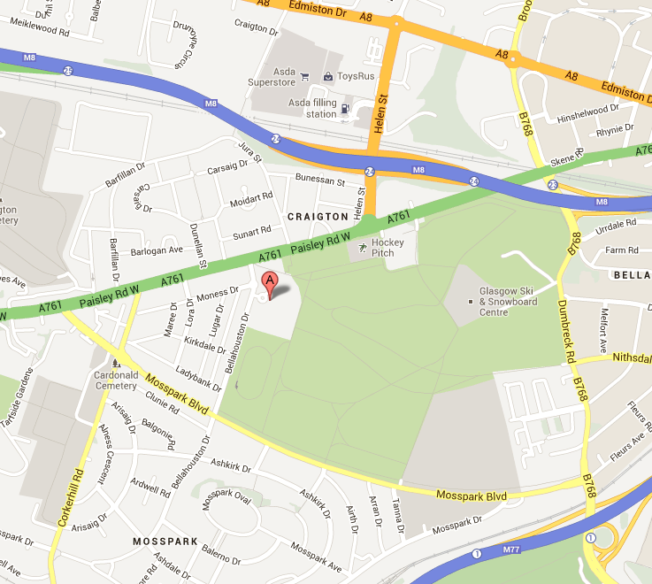

**Bellahouston Leisure Centre and Bellahouston Park**

**Address:** Bellahouston Leisure Centre, 31 Bellahouston Drive, Glasgow G52 1HH.

Parking is available at the leisure centre. Please be aware that parking may be limited given the number of competitors so additional car parking on nearby streets may have to be used. Please be respectful of local residents when parking.

**Registration and Transition Set Up:** **08:00 – 09:30 am**

Registration for the event will take place in Bellahouston Leisure Centre’s Sports Hall. Try to register on time and in particular please don’t wait until the last minute to go to registration.

If you are a Triathlon Scotland member you must bring your Race License. You may join Triathlon Scotland on the day.  
   
At registration you will be given a race pack containing:

ON THE OUTSIDE OF THE ENVELOPE:

A sticker giving your Name, Race number, Heat, Lane, Lane position, Cap colour and approximate heat start time.

INSIDE THE ENVELOPE:

1) Your race number. This should be pinned to the front of your t-shirt. If you are using a number belt the number should be visible to the REAR on the bike and to the FRONT on the run.

2) Two self adhesive numbers. Attach the helmet number to the front of your helmet. Attach the long number to the seat post or rear brake cable of your bike.

3) Photography registration form. If you or your family wish to take photos you they must complete this form. Hand it in to the photo registration desk in return for a sticker to say they are registered.

4) Extra stickers for supporters!

Swim hats and timing chips will be issued at the swim start. ***You must be very careful not to lose your timing chip. If you lose it you will have to pay £35.***

We will also mark your right arm and left leg with your race number. Please come dressed for this. Wear shorts and a t-shirt or your trisuit. If it takes you 30 seconds to get out your arm and leg that adds up to almost 3 hours for 350 competitors!

After you have registered you should proceed to the race transition area to set up your bike and other kit.  
  
GET YOUR BIKE CHECKED. You must affix the numbers to your bike and helmet before entering transition. Put on your helmet and do up the straps- they must be tight. A marshal or race official will check your helmet and bike.

All athletes will have a numbered space on a transition rack. You should rack your bike in the allocated space by carefully inserting the back wheel into the stand that holds the wheel. Lay out your running and cycle kit beside your bike taking care not to take up too much space. Practice walking into the transition area and over to your bike so that you will remember where to go to find your kit when the race starts.

You may have one adult in transition to help you set up before the race. Only competitors are allowed in transition during the race. Transition marshals will be available to provide assistance if required.

Marking your transition place with talcum powder, balloons etc. is not allowed.

**Race briefing: 09:40 – 10:00 COMPULSORY ATTENDANCE FOR ALL ATHLETES**

This is compulsory to attend for all athletes and will take place in the Sports Hall where you registered. You will be reminded of the rules to be observed during the event and advised of any last minute changes. The cycle and run routes will be pointed out to you and you can ask any questions.

**Race Rules**

This event is held under British Triathlon Rules. It is a Championship Race and referees will be in attendance. Rules will be enforced. Please familiarise yourself with the rule book.

<https://www.britishtriathlon.org/britain/documents/about/competition_rules.pdf>

We have highlighted some of the most important rules here:

**Helmets:**  For safety your bike helmet must be fastened before you touch your bike, remain fastened throughout the bike section and not be unfastened until you have racked your bike in transition.

**Course:**  Marshals and signage will guide you round the course.  However, it is the competitor’s responsibility to know and count the number of laps they must complete.

**Drafting:** All heats are NON-DRAFTING. You must stay 10m from the cyclist in front, unless overtaking.

**Outside Assistance:**  Outside assistance is not allowed.  Help may be provided to Tristar Start, 1, 2 and 3 athletes by marshals. Assistance from parents, friends etc. is not allowed at any point of the race.  Youth athletes may not receive assistance from anyone during the race. Since the race is non-drafting there is no wheel exchange facility. In the event of a puncture, athletes may 1) Repair it themselves using equipment they have carried, 2) Return to transition where the race mechanic will assist them or 3) Withdraw.

**External pacing:** You are obviously expected to encourage and support your child. However, running or cycling beside them and continually prompting them is not allowed.

**Race Number:**  This identifies you as a participant and must be displayed as instructed throughout the bike and run.  It must not be cut, folded or altered in any way.

**Transition**:  Kit must be placed in transition before the race start as indicated in information.  Access to transition once the race has started is not usually allowed for safety reasons. Your transition area should be as clear and tidy as possible, do not discard kit aimlessly and ensure you rack your bike and return it after the bike section in the correct space. Bikes MUST be racked by the REAR wheel.

Marking your transition place with talcum powder, balloons, etc. is not allowed.

**Riding in Transition:**  This is strictly forbidden.  Ensure you push your bike until you pass the mount line and get off before the dismount line at the end of the bike section.

**Ipods, MP3 players, phones etc:** You must not use these at any point during the race.

**Decency:** Nudity is not allowed. You must keep your chest covered on the bike and run. For girls a swim suit is acceptable. Boys who swim in trunks must put on a top in transition. If wearing a front zipping trisuit the zip must be fully fastened.

**Sportsmanship:** Please be polite and respectful to other competitors and marshals. Foul or indecent language will result in disqualification.

**Bikes:** The ends of your handlebars must have plugs in them. Since the cycle takes place on tarmac, athletes of 13 years or over may use aero bars. Age is taken as at 31st December in the current year.

There are no restrictions on the type of gear ratios your bike has.

**Rules for Parents/Guardians/Accompanying Adults:** Failure by a parent/guardian/ accompanying adult to carry out the instructions from officials, or failure to conduct him or herself in a proper manner may lead

to disqualification of the competitor or disciplinary action against the competitor by the appropriate Home Nation or British Triathlon. Misconduct by a parent/guardian/ accompanying adult may include, but is not limited to:

A. threatening, abusive or insulting words or conduct. B. failure to obey marshal’s/official’s instructions.

C. handing water bottles or any other equipment to, or collecting from, competitors. D. tampering with the equipment of others. E. unsporting impedance. It is acceptable to hand over prescription glasses.

**Races Start: 10:15**

You will need to be on poolside **AT LEAST 20 MINUTES before your heat’s start time**. Poolside marshals will instruct you on where to go to wait before your heat. A pool marshal will guide you to your swim lane and you will be given a swim hat to wear by your lane marshal. You must wear the allocated swim hat.

You will also be issued with your timing chip. Place it around your left ankle and be sure it is firmly fastened. If you lose it you will have to pay £35.

You will be allowed a couple of minutes for a swim warm up if you wish.

ALL SWIM HEATS HAVE A STAGGERED START. Your lane marshal will provide instructions. You will start at 5 second intervals in a pre-determined hat colour order.

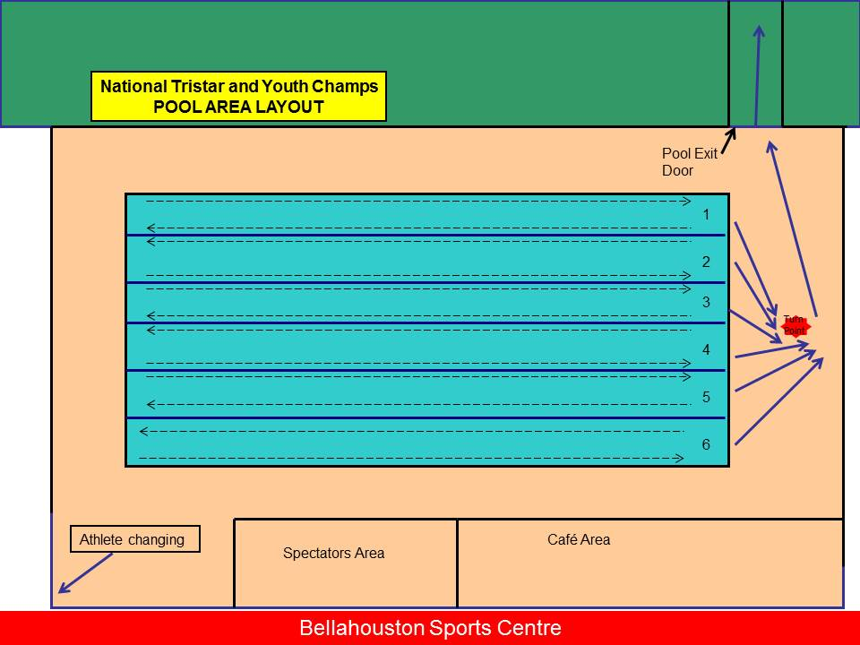

The lane marshal will tap you on the head with a float with 2 lengths to go (if tumble turning the float will be placed in the water so you can see it).

Spectators are not allowed in the pool area. There is ample viewing space through the windows.

**Transition 1 (Swim to Bike)**

At the end of the swim, climb out of the pool, go round the cone if in lane 1,2 or 3 and exit the poolside by the door at the left hand side of the pool.

The floor and your feet will be wet. Be careful not to slip.

THERE IS NO RUNNING ON POOLSIDE ALLOWED – EVERYONE WILL WALK.

If you are putting on any clothes or a race number belt do this at your bike. You must put on your helmet before you touch your bike.

**Bike**

Do not mount your bike until you exit the transition area and cross the designated MOUNT LINE on the cycle track.

The bike section consists of laps of a circuit marked out on fully closed roads within Bellahouston Park. Please keep to the left hand side of the paths and overtake on the right. Marshals and signage will keep you on the correct route. Please be aware of pedestrians and dogs throughout the park, although the marshals will try to keep the course clear, you must also keep a look out.

Please be careful when turning off the track as you head down the path towards Bellahouston Park. An almost 90 degree left-hand turn has been added to slow you down for safety purposes.

All heats are **NON-DRAFTING** (riders CANNOT ride in the slipstream of the rider in front and must keep a 10m gap except when overtaking).

**Transition 2 (Bike to Run)**

At the end of your bike laps, return to the transition area at the end of the lap round the cycle track. Dismount your bike on the track before the DISMOUNT LINE. Return your bike to your numbered space and place your bike back on the rack. Rack the bike using the REAR wheel. Only take your helmet off once the bike is safely stored.

**Run**

The run course is an all grass course for heats 1-4 (8’s and 9-10 yrs old) within the park and marshals will direct you in the right direction. Heats 5-15 (11-16yrs’s old) have a course that is mixed grass and tarmac paths. Water will be available at the start of first and second run laps.

*Please see run map for turning points. A marshal will direct you at the turning points.

**Finish**

Once you have crossed the finish line, you will receive a goodie bag and a race memento. You will need to have your timing chip removed from your ankle before leaving the finish area.

***You MUST return your chip or you will be charged £35.***

If you do not complete the race please let a marshal know that you have withdrawn. You must return your chip.

**Prize Giving & Results**

Prize giving will take place at around 14:00 (for Tristarts, Tristar 1 & 2) and 16:00 (Tristar 3 & Youth), next to the finish area. Full results will be posted on the club website [www.fusiontriathlonclub.co.uk](http://www.fusiontriathlonclub.co.uk) as soon as possible after the event.

**Photography**

There will be an official photographer there to take photos for Triathlon Scotland. These images may be used to promote the sport of triathlon. If you DO NOT WISH your child’s photo to be used in this way you must notify us at registration. Your child will be given a red wrist band to wear.

The images the photographer takes will be available for sale a few days after the event on their website

[www.imacimages.com](http://www.imacimages.com)

If parents and spectators wish to take photographs they must complete the photography registration form supplied in the competitor packs issued at registration. Hand this form to the photo registration desk where you will be issued with a sticker to confirm you have registered. You MUST NOT take photos of the swim or of transition. Please DO NOT publish your personal images of the event in a publically accessible area.

**Other stuff**

There will be other entertainment provided throughout the day, so you won’t be bored after your race is finished.

**Bike and Run Course Maps**

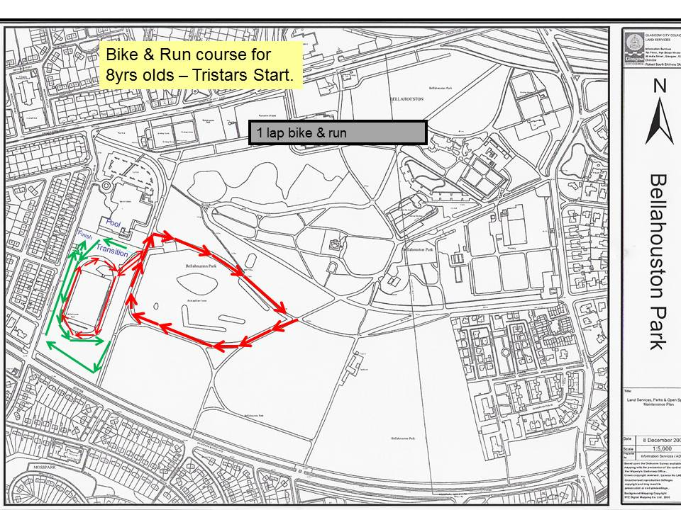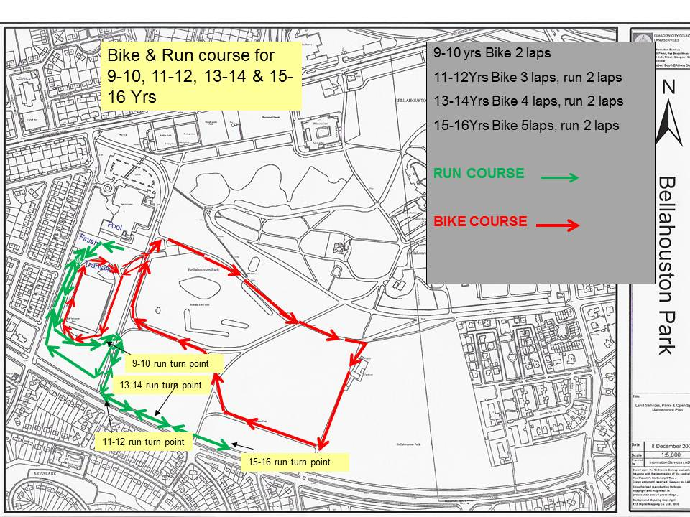

run 2 laps

**Guide for Spectators and Spectator Safety**

Spectating at a triathlon can be difficult. The three sports occurring in different area make it hard to follow your child.

We have provided this suggested plan to view the race at its best, and follow your child’s progress.

1. Watch the swim through the windows along the pool. Spectators are not permitted to enter the poolside.
2. Watch your child in transition along the side of transition between transition and the leisure centre.

PLEASE REMEMBER NO PHOTOGRAPHY OF THE SWIM OR TRANSITION

1. Move into the main park to watch your child cycle.
2. Move back past transition to the run and finish area.

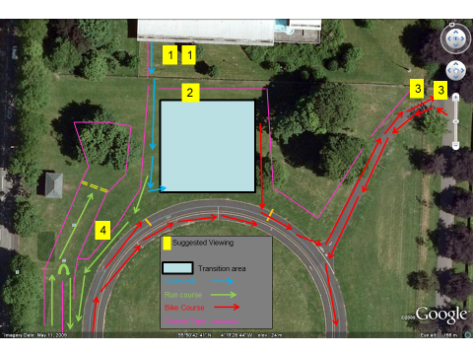

Occasionally access to part of the course is restricted to allow the athletes to compete in a fair manner, unhindered by spectators. For example, when athletes are exiting the pool you will not be able to cross there.

We request that spectators DO NOT CROSS the area between transition and the cycle track.

We also request that spectators DO NOT CROSS the cycle track to access the central island.

The only access from the bike to the run course will be through the area between the leisure centre and transition or at the far end of the cycle track.

**Questions?**

There will be a chance to ask questions at the briefing. If you have any urgent concerns please get in touch by e-mail [events@fusiontriathlonclub.co.uk](mailto:events@fusiontriathlonclub.co.uk)

Look forward to seeing you on the 23rd June.